Name______________________________________ Date:_________________

T: Investigation - Which materials are absorbent?

Object: | Sponge  or  Cloth | 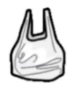  Plastic  bag  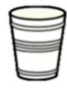  or  Cup | Foil | Cardboard  or  Paper | 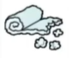  Cotton wool  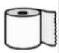  or  Tissue
Absorbent
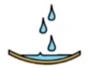
Waterproof

